Scholarly Results Report on the AIDA Analysis of Okada Manila as the Ultimate Family Destination
Prepared by: Engr. Jamie Eduardo Rosal, MSCpE
Dataset: [Capstone] Okada Manila UAI Survey (Responses).xlsx
Date of Analysis: June 3, 2026
Main Sample: 229 qualified family respondents

Abstract / Executive Summary
This scholarly results report presents an AIDA-based analysis of survey responses concerning Okada Manila's positioning as the Ultimate Family Destination in the Philippines. The analysis used 301 raw survey responses and retained 229 qualified family respondents who indicated that they have children. The results show high baseline awareness of Okada Manila (99.6%), strong family-staycation preference (70.7%), meaningful future booking intent (52.0%), and favorable repeat-visitation sentiment (81.7%). Overall, the evidence suggests that Okada Manila already possesses strong brand salience among family travelers, while additional gains may be achieved by converting awareness and desire into action through family-focused packages, digital storytelling, loyalty initiatives, and differentiated non-gaming experiences.
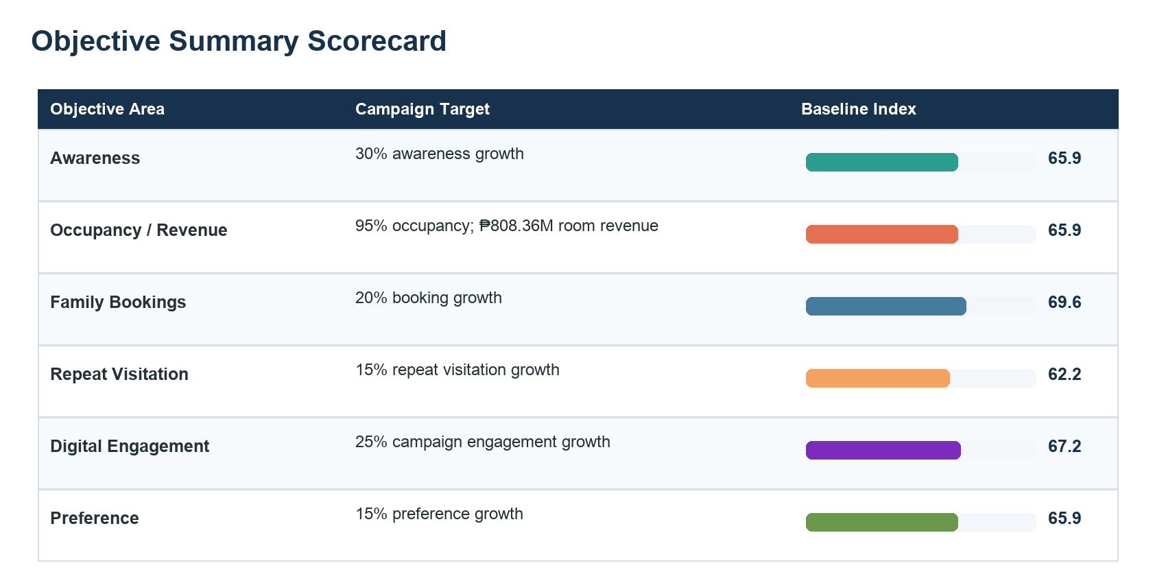
Figure 1. Objective summary scorecard based on survey-derived AIDA and campaign-relevant indicators.

Introduction
Okada Manila is widely recognized for luxury hospitality, entertainment, gaming, dining, and integrated resort experiences. The present analysis examines an opportunity to extend this brand relevance among Filipino families seeking premium staycations, family bonding, and leisure activities. The AIDA framework is appropriate for this evaluation because it traces a respondent's movement from brand awareness to interest, desire, and eventual action. In the context of family travel, this progression helps determine whether Okada Manila is merely known, actively considered, emotionally preferred, and behaviorally likely to receive bookings or repeat visits.
The report is written in third-person scholarly style and focuses on the empirical results of the survey. The findings are interpreted against six marketing objectives: awareness growth, occupancy and room revenue support, family booking growth, repeat visitation, digital campaign engagement, and preference growth among family travelers.

Methodology
The dataset was obtained from the workbook named [Capstone] Okada Manila UAI Survey (Responses).xlsx. The raw file contained 301 responses and 56 variables. The main analytic sample was defined by the family-traveler screening item, retaining respondents who answered that they have children. This rule produced the expected qualified sample of 229 respondents and excluded 72 rows without the qualifying child-screening response.
Data preparation involved renaming long survey items into compact analytic labels, removing identifiers from analytic tables, checking duplicate rows, documenting missingness, and converting ordinal and Likert-type items to comparable numeric measures. A cleaning caveat is noted because 2 qualified records selected 'No, I do not give my consent.' These rows were retained to match the expected qualified count but are disclosed for transparency.
The AIDA index used normalized 0 to 100 scores. Attention combined integrated-resort awareness, Okada familiarity, media exposure breadth, and offering-recognition breadth. Interest combined family-amenity consideration, family-amenity importance, prior family-event participation, and package-interest breadth. Desire combined likelihood to book a family-friendly luxury hotel, Okada stay budget, interest in family-oriented events, and interest in experiential packages. Action combined staycation readiness, prior Okada hotel stay, planned Okada family staycation, past and planned Okada non-staycation visit frequency, and return intention for family occasions.
Table 1. Data Cleaning and Qualification Summary
Data Quality Check | Result
Raw responses loaded | 301
Raw columns loaded | 56
Qualified family respondents | 229
Excluded rows without Q1 = Yes | 72
Qualified rows with no consent response | 2
Exact duplicate qualified rows | 0
Note. The main analysis uses the expected qualified family respondent sample.

Results

Respondent Profile
The sample was concentrated among adult family travelers in prime staycation decision-making age groups. The largest age group was 25 to 34 years old (36.2%), followed by adjacent working-age and parent-age segments. The profile supports the relevance of family staycation positioning because respondents were predominantly Filipino family decision-makers with children and measurable income diversity.
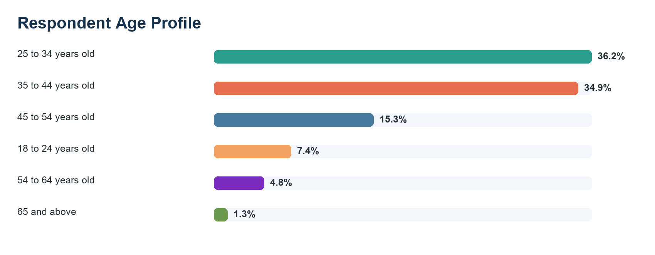
Figure 2. Respondent age profile among qualified family respondents.
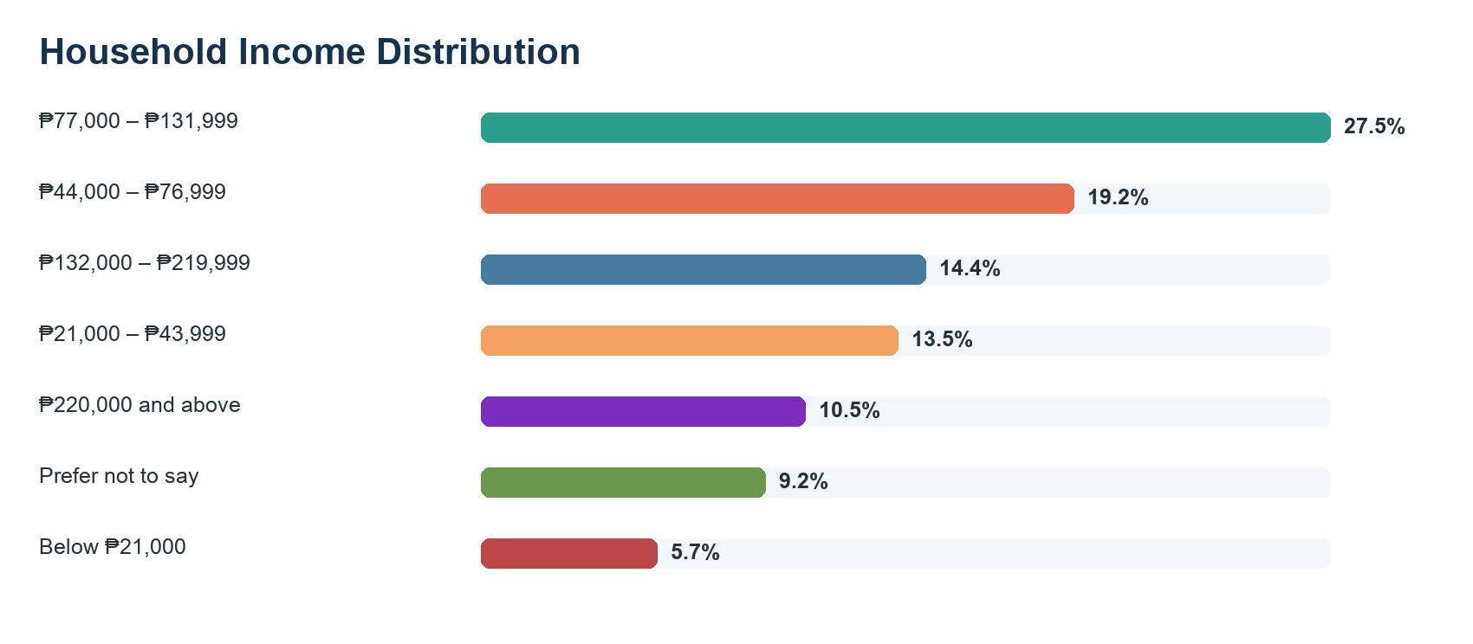
Figure 3. Household income distribution among qualified family respondents.
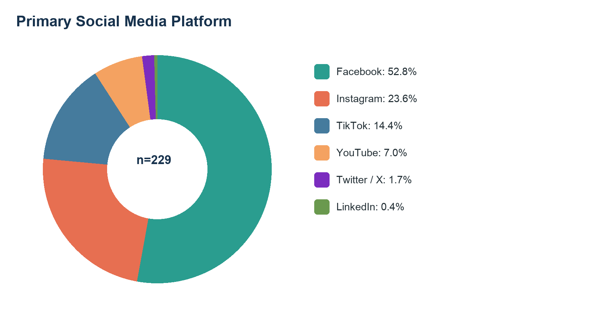
Figure 4. Primary social media platform used most often by qualified respondents.
Table 2. Respondent Profile Frequency Summary
Variable | Profile Category | Frequency | Percent
Age | 25 to 34 years old | 83 | 36.2
Age | 35 to 44 years old | 80 | 34.9
Age | 45 to 54 years old | 35 | 15.3
Age | 18 to 24 years old | 17 | 7.4
Age | 54 to 64 years old | 11 | 4.8
Age | 65 and above | 3 | 1.3
Gender | Woman | 122 | 53.3
Gender | Man | 106 | 46.3
Gender | Prefer not to say | 1 | 0.4
Primary Social Platform | Facebook | 121 | 52.8
Primary Social Platform | Instagram | 54 | 23.6
Primary Social Platform | TikTok | 33 | 14.4
Primary Social Platform | YouTube | 16 | 7
Primary Social Platform | Twitter / X | 4 | 1.7
Primary Social Platform | LinkedIn | 1 | 0.4
Note. Percentages are based on n = 229 qualified respondents.

AIDA Stage Results
The AIDA results indicate a relatively strong brand-funnel position. The mean Attention score was 65.9, Interest was 68.4, Desire was 69.6, and Action was 62.2. These values suggest that Okada Manila has a well-established awareness and desire base, while the action stage remains the most important area for conversion improvement.
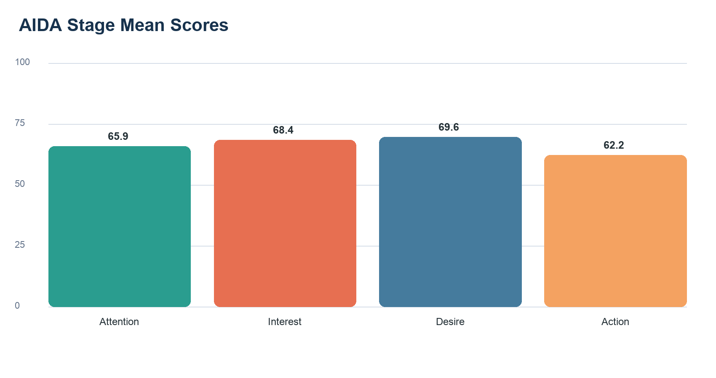
Figure 5. Mean AIDA stage scores on a normalized 0 to 100 scale.
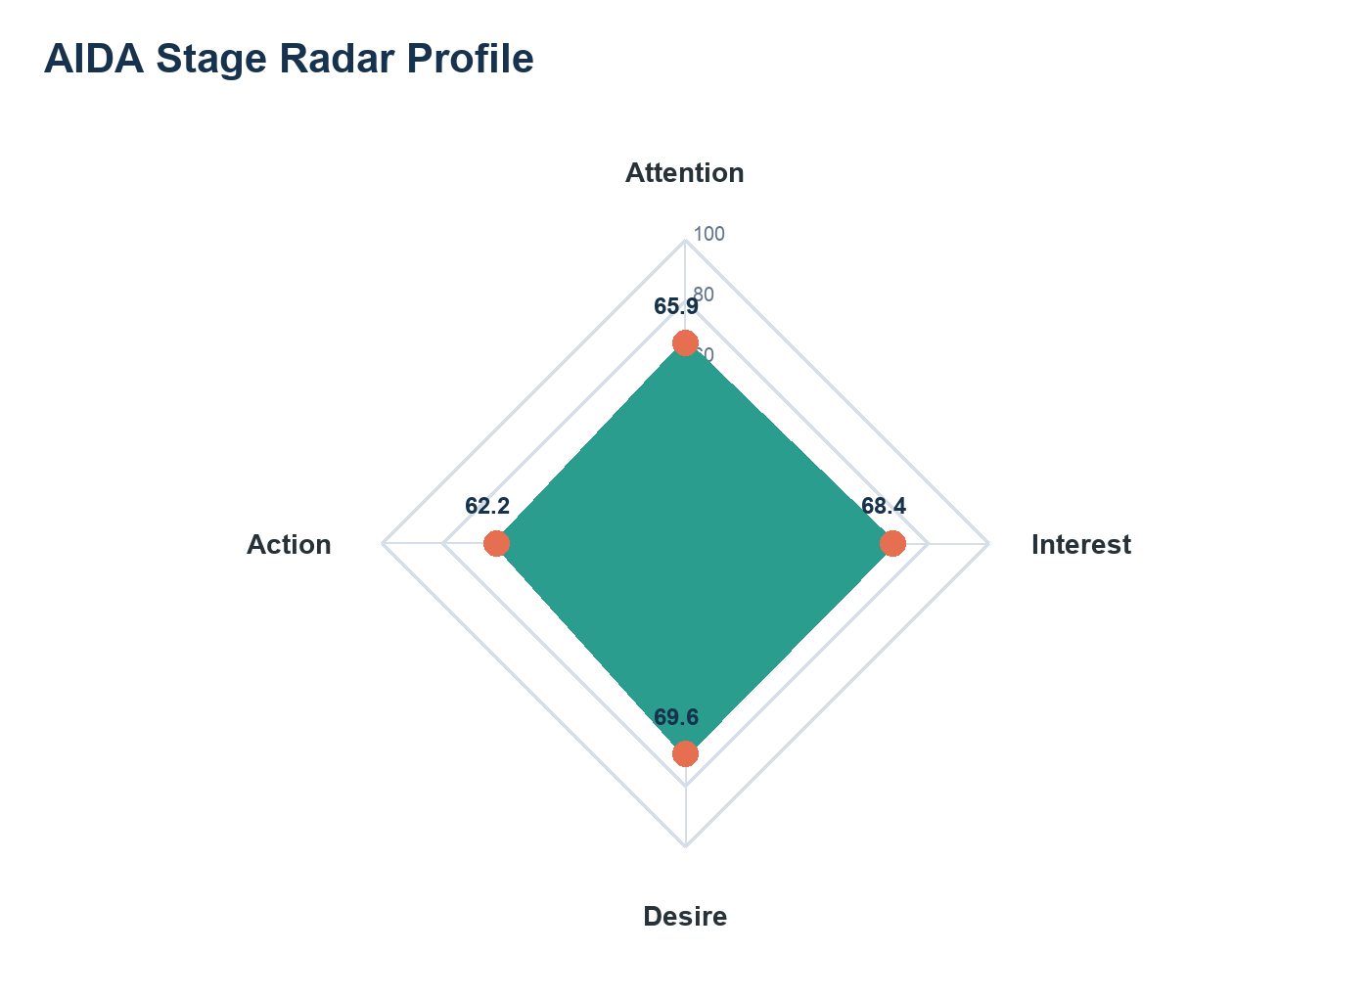
Figure 6. Radar profile of Attention, Interest, Desire, and Action.
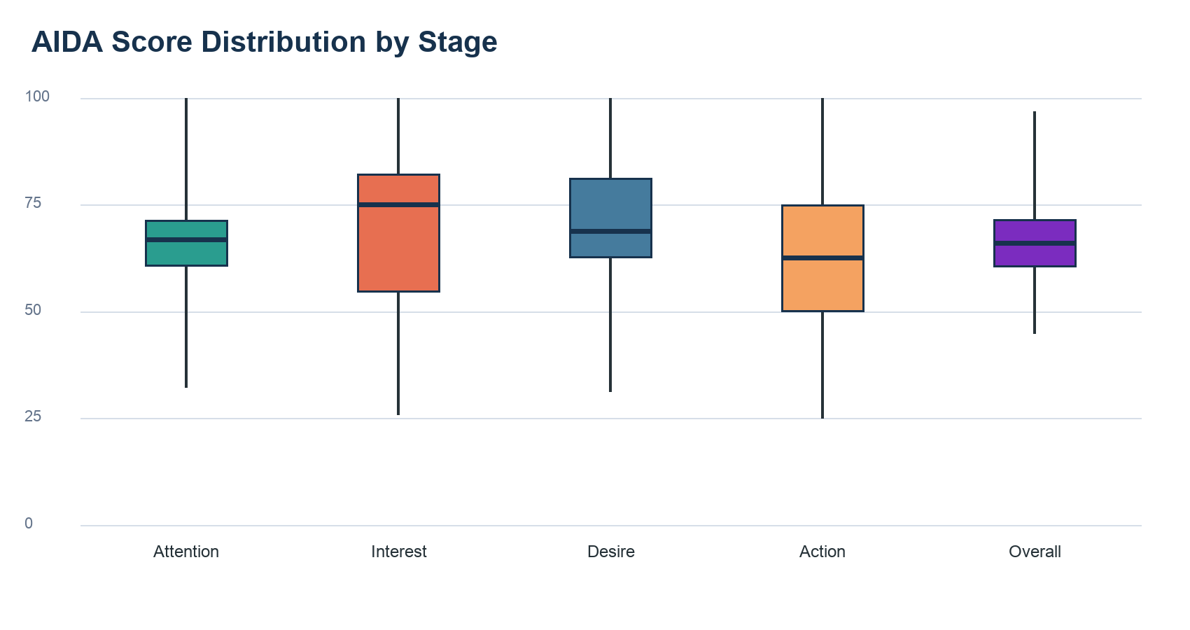
Figure 7. Distribution of AIDA scores across respondents.
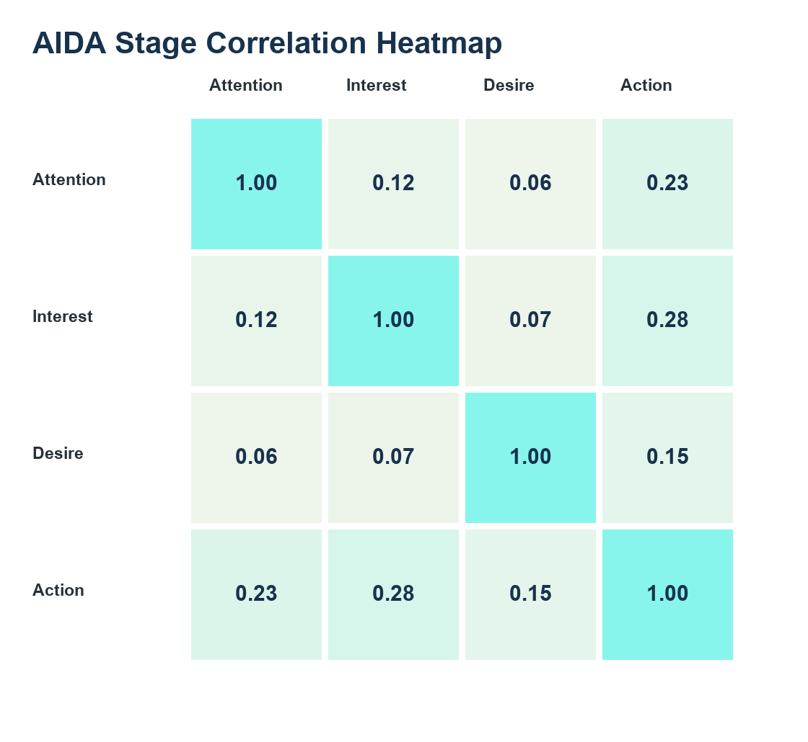
Figure 8. Correlation heatmap among AIDA stage scores.
Table 3. AIDA Stage Mean Scores
AIDA Stage | Mean Score
Attention | 65.9
Interest | 68.4
Desire | 69.6
Action | 62.2
Note. Scores are normalized from 0 to 100.
Table 4. AIDA Scoring Components and Mean Scores
AIDA Stage | Component | Mean Score
Attention | IR awareness of Okada | 99.6
Attention | Okada familiarity | 79.6
Attention | Okada media exposure breadth | 37.1
Attention | Okada offering awareness breadth | 47.5
Interest | Family-amenity consideration | 98.2
Interest | Family-amenity importance | 87.2
Interest | Prior family-event participation | 52.4
Interest | Package interest breadth | 35.9
Desire | Likelihood to book family-friendly luxury hotel | 76.3
Desire | Okada stay budget | 51.8
Desire | Interest in family-oriented events | 75.9
Desire | Interest in experiential family packages | 74.2
Action | Hotel/staycation readiness | 82.2
Action | Prior Okada hotel stay | 38.0
Action | Planned Okada family staycation | 63.0
Action | Past Okada visit frequency | 51.4
Action | Planned Okada visit frequency | 52.5
Action | Return intention for family occasions | 77.8
Note. Component means show the contribution of each survey-derived proxy to its AIDA stage.

Awareness, Preference, and Offering Recognition
Okada Manila demonstrated broad awareness among family respondents. The property was recognized by 99.6% of respondents in the integrated-resort awareness item, and 70.7% selected Okada Manila as the integrated resort they would most likely choose for a family staycation. This indicates that Okada Manila is not only known but also comparatively preferred in the family-staycation context.
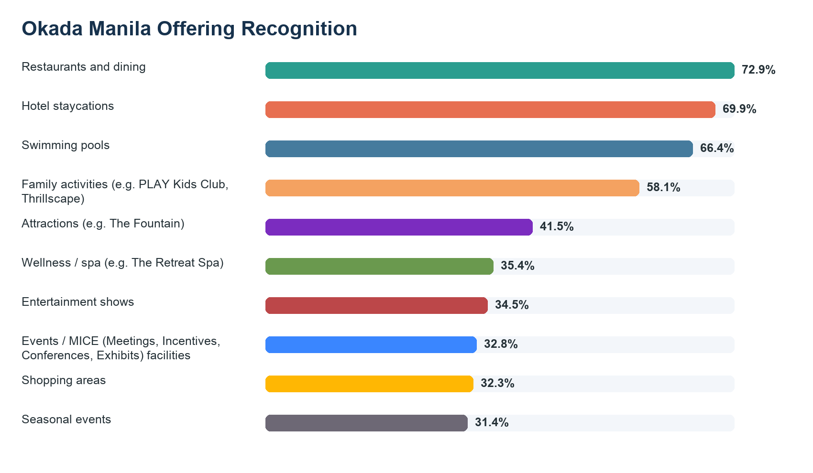
Figure 9. Recognition of Okada Manila offerings and facilities.
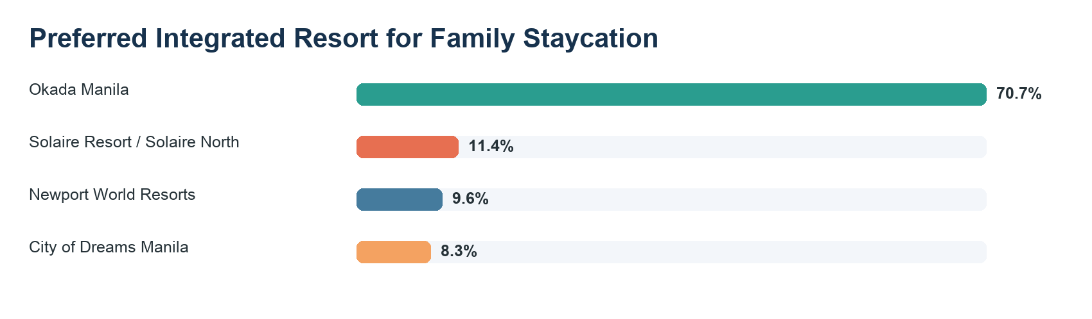
Figure 10. Preferred integrated resort for a family staycation in Metro Manila.
Table 5. Preference and Competitor Frequency Summary
Measure | Category | Frequency | Percent
Family Staycation Preference | Okada Manila | 162 | 70.7
Family Staycation Preference | Solaire Resort / Solaire North | 26 | 11.4
Family Staycation Preference | Newport World Resorts | 22 | 9.6
Family Staycation Preference | City of Dreams Manila | 19 | 8.3
Perceived Strongest Competitor | Solaire Resort | 105 | 45.9
Perceived Strongest Competitor | Newport World Resorts | 66 | 28.8
Perceived Strongest Competitor | City of Dreams Manila | 58 | 25.3
Note. Preference and competitor measures provide evidence for positioning and differentiation decisions.

Booking Drivers, Package Interest, and Revenue-Relevant Indicators
Booking decisions were strongly influenced by value and family relevance. The leading booking factor was Price/promos (28.4%), and the most preferred family package was Weekend family getaway (33.2%). The leading room type was Deluxe Room (55.0%), while the most common Okada stay budget was ₱10,000–₱14,999 (34.1%). These results suggest that premium positioning should be paired with concrete family benefits and carefully structured package value.
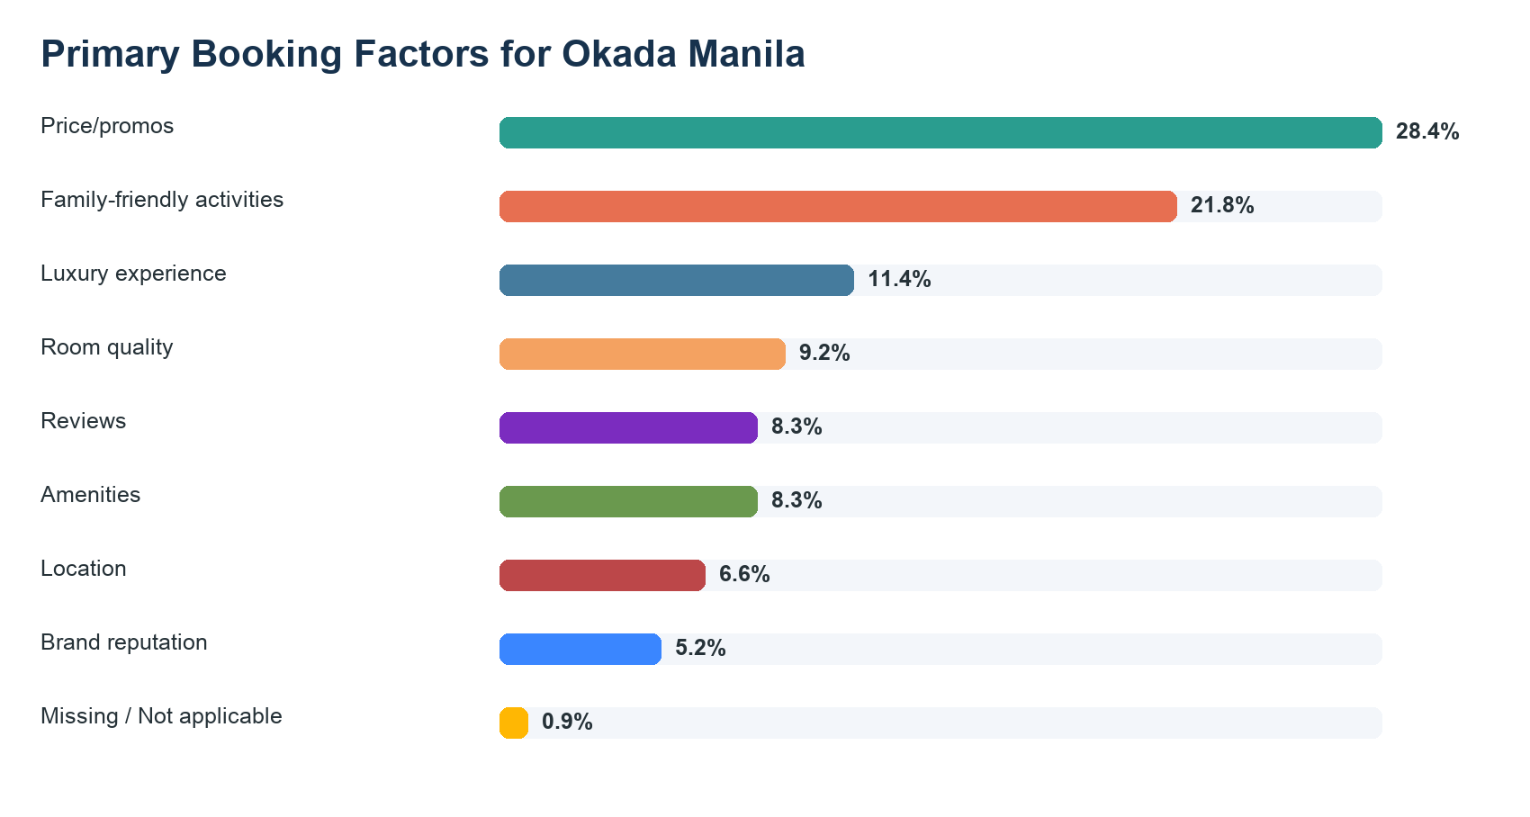
Figure 11. Primary booking factors influencing a stay at Okada Manila.
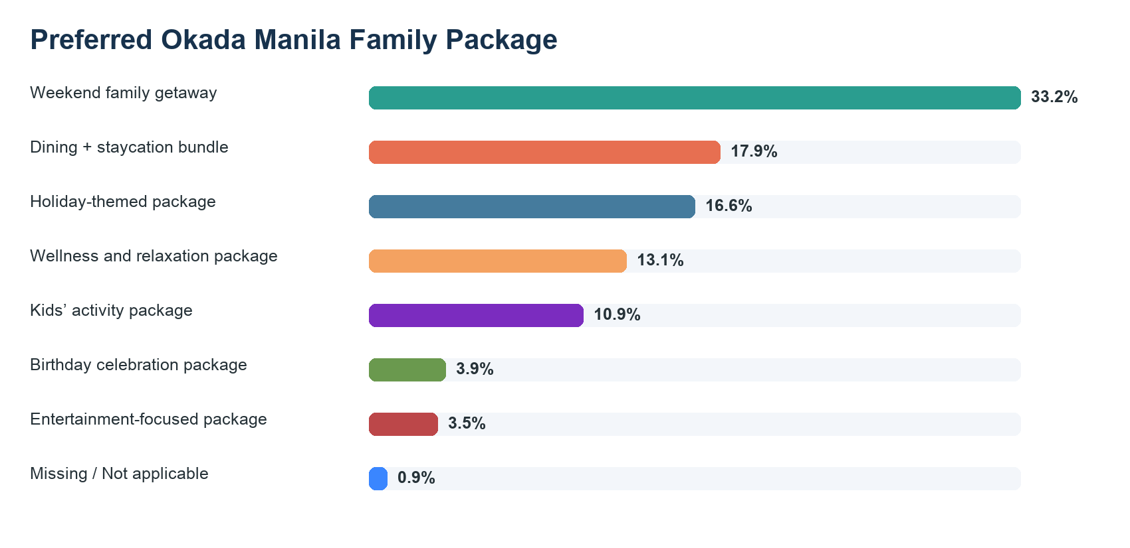
Figure 12. Preferred family package concepts for Okada Manila.
Table 6. Booking Factor and Package Preference Summary
Measure | Category | Frequency | Percent
Booking Factor | Price/promos | 65 | 28.4
Booking Factor | Family-friendly activities | 50 | 21.8
Booking Factor | Luxury experience | 26 | 11.4
Booking Factor | Room quality | 21 | 9.2
Booking Factor | Reviews | 19 | 8.3
Booking Factor | Amenities | 19 | 8.3
Booking Factor | Location | 15 | 6.6
Booking Factor | Brand reputation | 12 | 5.2
Family Package | Weekend family getaway | 76 | 33.2
Family Package | Dining + staycation bundle | 41 | 17.9
Family Package | Holiday-themed package | 38 | 16.6
Family Package | Wellness and relaxation package | 30 | 13.1
Family Package | Kids’ activity package | 25 | 10.9
Family Package | Birthday celebration package | 9 | 3.9
Family Package | Entertainment-focused package | 8 | 3.5
Note. The table identifies conversion levers for family booking growth.

Repeat Visitation and Digital Engagement
Repeat visitation indicators were favorable. Although 38.0% of qualified respondents had previously stayed at Okada Manila, 81.7% agreed or strongly agreed that they would return for family occasions or celebrations. Interest in additional family-oriented events reached 80.3%, while interest in experiential family packages reached 76.0%. These findings indicate that future engagement can be strengthened through event calendars, loyalty privileges, and experience-led post-stay communications.
Digital engagement opportunities are also evident. The most used social media platform was Facebook (52.8%). Okada Manila exposure appeared across Facebook, Instagram, TikTok, YouTube, influencers, online articles, online travel agencies, and family or peer recommendations. The channel profile supports an integrated digital campaign that combines social storytelling, influencer content, and conversion-oriented booking links.
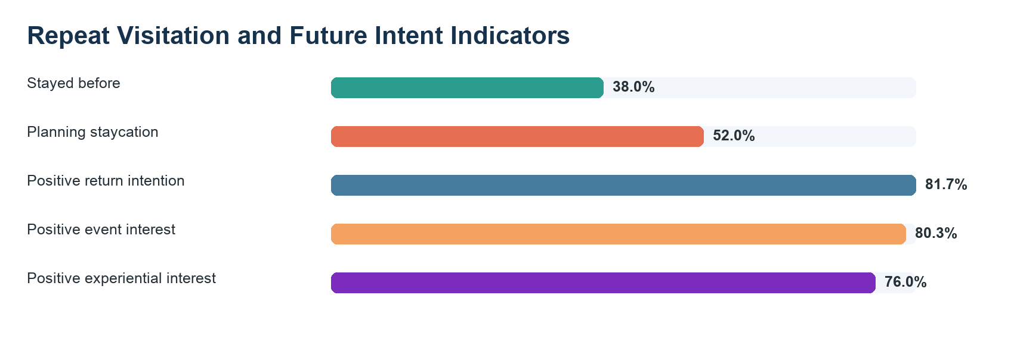
Figure 13. Repeat visitation and future intent indicators.
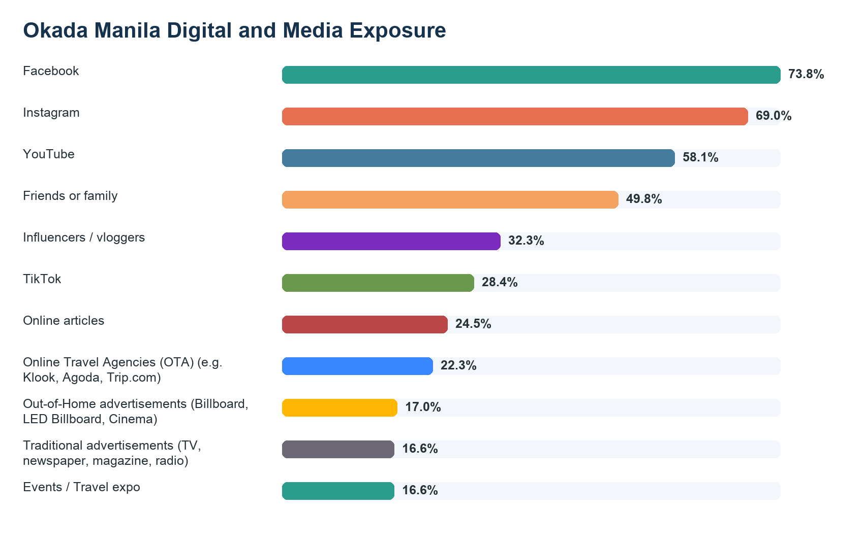
Figure 14. Okada Manila digital and media exposure sources.

Objective-Level Analysis

Objective 1: Increase Awareness by 30%
The findings indicate that the awareness objective begins from a strong baseline. Okada Manila awareness reached 99.6%, and the Attention score reached 65.9. Because general awareness is already high, the campaign's 30% awareness-growth target should be interpreted as growth in family-friendly associations rather than simple name recognition. The most defensible strategic direction is to increase the visibility of non-gaming family experiences, including hotel staycations, pools, restaurants, seasonal events, family activities, and attractions.

Objective 2: Maintain 95% Occupancy and Support ₱808.36 Million Annual Room Revenue
The results suggest that family travelers can contribute to occupancy stabilization when packages are aligned with their spending expectations and preferred stay formats. The most common budget band was ₱10,000–₱14,999, and the leading room preference was Deluxe Room. These findings imply that the occupancy and room revenue target should be supported by short-stay family bundles that emphasize premium value, family inclusions, and seasonal urgency. The report does not independently validate the ₱808.36 million projection, but the survey results identify demand-side signals that may support the target.

Objective 3: Increase Family Hotel Bookings by 20%
The Desire score of 69.6 indicates that respondents are receptive to a family-friendly luxury proposition. The strongest package preference was Weekend family getaway, and the leading booking driver was Price/promos. Therefore, a 20% increase in family hotel bookings should be pursued through clearly differentiated packages rather than broad discounting alone. Weekend family getaways, dining-and-staycation bundles, holiday-themed packages, wellness packages, and kids' activity packages should be presented as bookable options with visible inclusions.

Objective 4: Improve Repeat Visitation by 15%
The repeat-visitation objective is supported by favorable attitudinal evidence. While 38.0% of respondents had already stayed at Okada Manila, 81.7% reported positive return intention for family occasions or celebrations. This gap suggests a conversion opportunity: post-stay communications, birthday and milestone offers, family privileges, and loyalty-linked event invitations can help convert favorable intent into repeat visitation.

Objective 5: Increase Digital Campaign Engagement by 25%
The digital campaign objective is supported by respondents' social media behavior and exposure pathways. Facebook was the most used social media platform, and Okada Manila was commonly encountered through social and digital channels. The campaign should use family-oriented storytelling, influencer collaborations, user-generated family content, short-form video, and package-led creative. Engagement metrics should prioritize clicks to family packages, saves, shares, comments, inquiries, and booking-path actions.

Objective 6: Increase Preference by 15%
Okada Manila already held a strong preference baseline, with 70.7% selecting it as the preferred integrated resort for a family staycation. The strongest perceived competitor was Solaire Resort (45.9%), while the strongest preference driver was Family-friendly atmosphere (68.6%). Preference growth should therefore focus on differentiation: Okada Manila should make its family-friendly atmosphere, amenities for children, safety and comfort, dining, room quality, entertainment, and premium family experiences more visible and easier to act upon.

Table 7. Objective-by-Objective Findings Matrix
Objective Area | Campaign Target | Baseline Evidence | Strategic Implication
Awareness | 30% awareness growth | 99.6% aware; Attention 65.9 | Build family-specific awareness associations.
Occupancy / Revenue | 95% occupancy; ₱808.36M room revenue | Top budget: ₱10,000–₱14,999 | Align packages with spending bands and short-stay demand.
Family Bookings | 20% booking growth | Desire 69.6; top package: Weekend family getaway | Convert desire through themed, bookable family offers.
Repeat Visitation | 15% repeat visitation growth | 81.7% positive return intention | Use loyalty, milestone, and post-stay communications.
Digital Engagement | 25% engagement growth | Top platform: Facebook | Prioritize social storytelling and influencer-led content.
Preference | 15% preference growth | 70.7% prefer Okada Manila | Differentiate through family amenities and non-gaming experiences.
Note. Each objective is paired with the strongest survey evidence and a strategic implication.

Discussion
The AIDA funnel suggests that Okada Manila has a favorable upper-funnel and mid-funnel position among qualified family respondents. Attention is supported by high awareness and familiarity, while Desire is supported by strong receptiveness to family-friendly luxury positioning and future experiential offerings. The principal strategic challenge lies in strengthening the transition from Desire to Action. In practical terms, this means that campaign investments should not only inform families about Okada Manila but also make family booking decisions easier, more emotionally compelling, and more immediately actionable.
The results also indicate that family travelers evaluate integrated resorts through a mix of emotional, functional, and economic considerations. Family-friendly atmosphere, amenities for children, safety and comfort, room quality, dining, entertainment, and price or promotional value all matter. A successful marketing strategy should therefore avoid positioning family packages as simple room discounts. Instead, packages should be communicated as complete family experiences that combine convenience, bonding, premium leisure, and memorable activities.

Conclusion and Recommendations
The study concludes that Okada Manila is already strongly positioned in awareness and preference among surveyed family travelers, but additional growth depends on converting this favorable perception into repeatable family booking behavior. The evidence supports a marketing strategy centered on family-focused digital communication, experience-led staycation packages, seasonal events, loyalty privileges, and differentiated non-gaming attractions.
- Strengthen family-specific brand associations by consistently showing non-gaming amenities, children's activities, family dining, seasonal events, and premium bonding experiences.
- Use package architecture to convert desire into bookings, with clear inclusions for weekend getaways, dining bundles, holiday themes, wellness, and kids' activities.
- Prioritize social and digital channels, especially Facebook and visually rich platforms, using influencer content and family-generated stories.
- Develop repeat-visitation programs tied to birthdays, school breaks, holidays, and family milestones.
- Track the AIDA stages over time so campaign performance can be evaluated against the 2027 objectives.

Appendix A: AIDA Scoring Rubric
Table A1. AIDA Scoring Rubric
AIDA Stage | Survey Items | Construct Represented
Attention | Q23, Q26, Q27, Q29 | Awareness, familiarity, exposure breadth, offering recognition
Interest | Q8, Q14, Q18, Q20 | Consideration, importance of amenities, event participation, package interest
Desire | Q22, Q34, Q37 events, Q37 experiential | Likelihood, budget, event interest, experiential package interest
Action | Q5, Q30, Q31c, Q31b, Q31e, Q37 return | Readiness, prior stay, planned stay, visit frequency, return intention
Note. All AIDA values were normalized to a 0 to 100 scale.

Appendix B: Selected Frequency Tables
Table B1. Selected Stay and Booking Frequency Results
Measure | Category | Frequency | Percent
Stay Length | 1 night | 117 | 51.1
Stay Length | 2 nights | 83 | 36.2
Stay Length | More than 2 nights | 27 | 11.8
Stay Length | Missing / Not applicable | 2 | 0.9
Okada Budget | ₱10,000–₱14,999 | 78 | 34.1
Okada Budget | ₱15,000–₱19,999 | 77 | 33.6
Okada Budget | ₱20,000–₱29,999 | 50 | 21.8
Okada Budget | ₱30,000 and above | 22 | 9.6
Okada Budget | Missing / Not applicable | 2 | 0.9
Planning Okada Staycation | Yes | 119 | 52
Planning Okada Staycation | No | 70 | 30.6
Planning Okada Staycation | Missing / Not applicable | 40 | 17.5
Note. Missing or branch-skipped values are retained where applicable.

